Pre-Brief v2.7

User Guide
Pre-Brief sends you a written brief 30 minutes before every meeting it is tracking. Who you are meeting, the last three touchpoints, open commitments on both sides, and one suggested talking point.
As of v2.7 it also fills in that history for you. After a meeting, Pre-Brief files the Gemini notes into a folder for that person and reads them, so the touchpoints and commitments behind the next brief are written without anyone typing them.
This guide covers running it day to day. For first time setup, see the Installation Guide.

What arrives, and when
Thirty minutes before a matched meeting, a brief lands in Slack, and in email too if you turned that on:
- Who you are meeting, with role and company
- Where you left off, one or two lines on what was decided last time and what is now owed
- Last three touchpoints, most recent first
- Open commitments, both what you owe and what they owe, with due dates
- One suggested talking point
The “Where you left off” line is written for someone who was in that meeting, so it leads with what was decided or what is outstanding rather than narrating the conversation back to you. It needs an API key. Without one the brief still sends, it just starts at the touchpoint list.
Briefs are sent once per meeting. If a meeting repeats weekly, each occurrence gets its own brief. Nothing is ever sent twice for the same occurrence, even if the schedule is checked dozens of times.

The four tabs
Setup is a read only status page. Run Pre-Brief, then Check my setup to refresh it.
Contacts is the people and recurring meetings you want briefs for. One row each. Rows with a Relationship of Recurring meeting are group meetings tracked by title rather than by person.
Column | What it does
Contact Key | Their email address, or series: plus a meeting title for a recurring group meeting. This is how meetings get matched, so it must be exact. Filled in for you when notes are filed.
Name, Company, Role | Shown at the top of the brief.
Relationship | Free text. Investor, customer, mentor, recruiter, whatever is useful.
Suggested Talking Point | Your fallback. Used whenever AI generation is off or unavailable.
Active | TRUE by default. Set it to FALSE to stop briefing on someone without deleting their history.
Touchpoints is your meeting history. Date, whose contact key it belongs to, the type, and a summary. The three most recent are used. Rows filed automatically also carry a Source of Gemini notes and a Notes Link to the full document, which the brief includes.
Commitments is who promised what. Contact key, owner, the commitment, a due date, and a status of Open or Done. Anything marked Done is ignored. The five soonest open items are used. A Source of Gemini notes means the row came out of a meeting rather than your keyboard.
Delivery Log is the audit trail. Every brief, when it went, which channels carried it, and whether the talking point was generated or came from your Contacts column.

Where the history comes from
Pre-Brief can fill the Touchpoints and Commitments tabs for you.
Once a day it looks back over the past 24 hours of calendar events. Google’s Gemini attaches its notes to the meeting invite on its own after a call. Pre-Brief reads that attachment. For any meeting that has one, it does four things:
- Files a copy of the notes into a private Drive folder for that person, named by date so the folder reads as a timeline of the whole relationship. The original is left untouched.
- Writes the notes summary into Touchpoints, with a link back to the filed copy.
- Turns each of Gemini’s suggested next steps into a row in Commitments, with an owner and a due date where one was stated.
- Adds anyone new to Contacts automatically. Nothing to approve. Their first meeting has no prior history to brief on, so the first brief they trigger is the one before your second meeting with them.
Rows written this way are marked Gemini notes in the Source column. Anything you type yourself stays blank there, so you can always tell the two apart.
Notes are filed once. Running the job repeatedly never duplicates a row.
Pre-Brief never writes to your calendar. It reads events and it reads attachments. It does not attach anything, does not change an invite, and does not create meetings. Nothing it does is visible to anyone else on an invite.
Your archive is private. A Drive copy does not carry the original’s sharing, so the filed copy belongs to whoever runs Pre-Brief and inherits only the archive folder’s permissions. Who can see the original notes doc on the invite is decided by Google when Gemini creates it, and Pre-Brief neither widens nor narrows that.
This needs Gemini meeting notes. That is a Google Workspace feature, so the automatic path does not work on a personal Google account. Everything else in Pre-Brief does. If you do not have Gemini notes, keep filling the tabs by hand and the briefs are identical.
Run it now: Pre-Brief, then File meeting notes now.
Leave it running: Pre-Brief, then Turn on automatic note filing. It runs early each morning.
See the archive: Pre-Brief, then Open my notes archive. Share that folder with anyone who needs the history and every future contact folder inherits the share.

Two habits still worth keeping
Automatic filing covers what was said in meetings. It cannot see what happened outside them.
Add a touchpoint after a call or exchange that had no Gemini notes attached. Two sentences on what they actually care about beats a full transcript.
Check the commitments occasionally. Gemini writes next steps in plain language, and the owner it names is the one Pre-Brief records. If a row reads wrong, edit it in the Sheet. Mark items Done as they land.

Getting a meeting briefed
Pre-Brief matches a calendar event three ways.
By guest. If someone in your Contacts tab is invited to the meeting, it matches automatically. Nothing to do.
By meeting title. If the meeting has two or more other attendees, Pre-Brief tracks it as a recurring meeting rather than a person. “Engineering Standup” gets its own folder, its own history, and its own brief, exactly the way a person does. The title is matched loosely, so “Weekly Sync (Aug 18)” and “Weekly Sync (Aug 25)” land in the same place rather than creating a folder every week.
By marker. Put this line anywhere in the event description:
PREBRIEF: someone@example.com
Use the same address as the Contact Key. The marker takes priority over both guests and titles, which is useful when the meeting is with a person who is not the calendar invitee, or when a group meeting should be filed under one person instead.
All day events are always skipped.

Keeping it useful
The brief is only as good as the three tabs behind it. Two habits are enough.
After a meeting, add one row to Touchpoints. Two sentences on what they actually care about beats a full transcript. The generator reads for substance, not volume.
When someone promises something, add a row to Commitments. This is the highest value data in the system. Dropped verbal commitments are the biggest credibility leak most executives have, and this is the only tab that closes it. Mark items Done as they land.
You do not need to fill in everything. A contact with no history still produces a brief, it just leans on the Suggested Talking Point column.

About the talking point
Every brief ends with one suggested talking point. Where it comes from depends on what you have set up, and it is never blank.
With a Google AI Studio key, it is written fresh for each meeting from that contact’s history and open commitments.
It follows a priority order. A commitment you owe and is due soon comes first. Then a commitment they owe. Then any other open commitment. Only when nothing is outstanding does it draw on meeting history.
Without a key, or if the AI is slow or unavailable, Pre-Brief builds one from the record instead. It walks the same priority order and states the fact plainly, for example “You owe Marcus this: Send the revised pricing deck. Due Aug 21. Lead with it before it comes up.” Nothing is generated, so it cannot fail or invent anything.
If you would rather write it yourself, fill in the Suggested Talking Point column in the Contacts tab. Anything you put there wins over both of the above, for that contact, on every brief.
The Delivery Log records which of the three was used and why, so you can always tell.
This means a brief never fails to arrive because an AI service was slow, and it never arrives with an empty talking point. Without a key it is blunter and more factual. With one it is sharper.

Reading the Delivery Log
Status | Meaning
SENT | Delivered. The Detail column names the channels and the talking point source.
ERROR | Delivery failed. Detail carries the reason. It will retry on the next check.
PENDING | Written just before sending. If one is stuck here, the script stopped mid send.
Only SENT counts as delivered, so a failed brief is automatically retried while the meeting is still inside the 30 minute window.

Common questions
A meeting did not get briefed. Check three things in order. Is the person in Contacts with Active set to TRUE. Does the Contact Key exactly match the guest email or the PREBRIEF: marker. Was the meeting created less than 30 minutes before it started, which leaves no window to fire in.
Briefs stopped arriving. Run Pre-Brief, then Check my setup. The most likely answer is that automatic briefs are off, or that the Slack webhook was revoked.
The talking point reads generic. That contact has thin history. Add a touchpoint or two with real specifics, or write the fallback yourself in the Contacts tab.
I want a different lead time. Ask whoever set this up. It is one number near the top of the script.
A meeting’s notes did not get filed. Three usual causes. The notes doc was not attached to the calendar event. The event had no other attendees at all, so there is nobody and no group to file it under. Or the notes were already filed on an earlier run.
A recurring meeting made two folders. Its title changed by more than the date. Pre-Brief strips dates, weekday names, and trailing numbers from titles, but a genuine rename reads as a new meeting. Merge the folders in Drive and delete the spare row from Contacts.
A commitment has the wrong owner. Pre-Brief records whoever Gemini named in the next step. Edit the row in the Sheet, it is read fresh on every brief.
Your own commitments are filed under your name instead of as You. Your name is not saved, or it is saved differently from how the notes write it. Run Pre-Brief, then Set my name, and enter it as it appears in the notes.
You want to check the whole thing works. Run Pre-Brief, then Run the notes self-test. It manufactures two realistic meetings, files them for real, and prints what it extracted, then Clean up the self-test removes every trace. Useful after any change, and the fastest way to see the system work before you have real notes to feed it.
Someone else should get the briefs. Run setup again and enter their Slack webhook, their email address, or both. Useful if an assistant is running this on behalf of an executive.
I want to stop briefing on one person. Set their Active cell to FALSE in the Contacts tab. Their notes keep filing to Drive, the briefs just stop.

Privacy notes
Everything runs inside your own Google account. There is no server, no third party service, and no shared database.
The Sheet holds the meeting history, so treat it like any confidential document and share it accordingly. The same goes for the notes archive folder in your Drive, which holds full copies of every meeting note Pre-Brief has filed.
Your Slack channel should be private, with only you in it. That is how the Installation Guide sets it up, and it is worth checking if someone else configured this for you.
Everyone who can read that channel can read every brief, which means the touchpoint summaries and every open commitment in both directions. They cannot open the linked notes without Drive access, but the summary text sits right there in the message. Never point Pre-Brief at a team channel.
A private channel is private from colleagues, not from your employer. Workspace owners can export private channels on paid plans. If the meeting content is sensitive enough that this matters, use email delivery instead.
If you use AI talking points, the contact’s name, role, recent touchpoints, and open commitments for that one person are sent to Google’s Gemini API to produce the sentence. Nothing else leaves. If that is not acceptable for your context, leave the API key blank and write talking points yourself. Every other feature works identically.

The menu
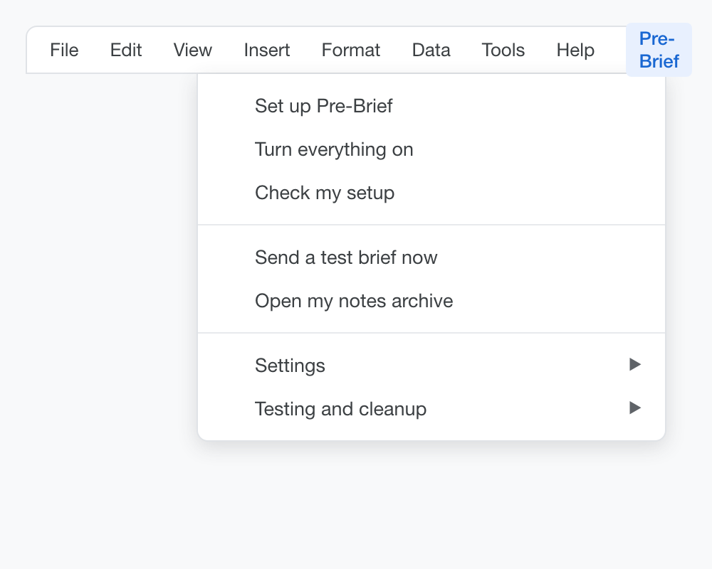
The Pre-Brief menu
Day to day, the top five are all you need.
Item | What it does
Set up Pre-Brief | Walks the four setup questions. Safe to re-run.
Turn everything on | Starts both the calendar checks and the daily note filing. One switch.
Check my setup | Refreshes the Setup tab so you can see what is on.
Send a test brief now | Creates a demo meeting and briefs it immediately.
Open my notes archive | Shows the Drive folder holding the per-contact history.
Everything else lives in two submenus, and most people never open them.
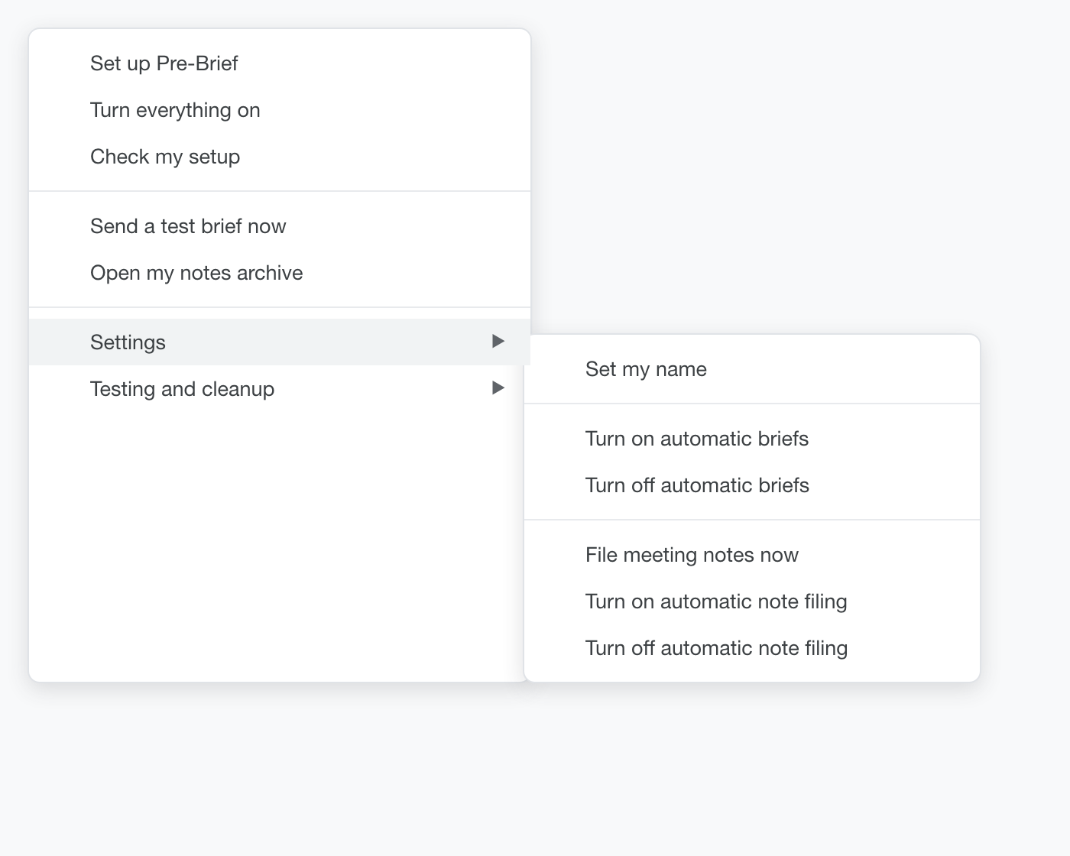
The Settings submenu
Settings
Item | What it does
Set my name | The name you go by in meeting notes. Decides which commitments show as yours.
Turn on automatic briefs | Starts checking the calendar every five minutes.
Turn off automatic briefs | Stops the checks. Deletes nothing.
File meeting notes now | Files recent Gemini notes immediately instead of waiting for tomorrow.
Turn on automatic note filing | Runs that filing job once a day, early.
Turn off automatic note filing | Stops the daily filing. Files already in Drive are untouched.
Testing and cleanup
Item | What it does
Run the notes self-test | Builds two realistic meetings, files them, and shows what it extracted.
Clean up the self-test | Removes everything the self-test created.
Schedule an unattended test | Creates a meeting 35 minutes out, then waits for the scheduler to catch it.
Delete demo calendar events | Removes the synthetic test meetings.
Clean up before sharing | Clears test history and demo events. Keeps contacts and settings.

Pre-Brief v2.7. User Guide. August 2026.

