Pre-Brief v2.7

Installation Guide
Pre-Brief sends you a written brief 30 minutes before every meeting it is tracking. Who you are meeting, the last three touchpoints, open commitments on both sides, and one suggested talking point. If your meetings produce Gemini notes, it also builds that history for you instead of asking you to type it.
Setup takes about five minutes. You need a Google account. Everything else is optional.

Before you start
Required: a Google account, personal or Workspace. That is genuinely all.
Recommended: a Slack workspace where you can create an app. Slack is the default delivery channel. See Appendix A, it takes about two minutes.
Optional: a Google AI Studio API key, free, if you want talking points written for you instead of typed by you.
Optional: Google Workspace with Gemini meeting notes, if you want the meeting history filled in automatically. This is the only feature that a personal Google account cannot run. Everything else works identically without it.
Pre-Brief works without any of the optional items. If you skip Slack, email delivery needs no configuration at all.

Step 1. Copy the Sheet
Open the Pre-Brief template, then choose File, then Make a copy.
Pre-Brief template
The automation code lives inside the Sheet, so copying the Sheet copies the code with it. You get your own private instance and nothing is shared back.
Name it whatever you like. The automation code travels inside the Sheet, so copying it gives you your own private working instance. Nothing is shared back to anyone.

Step 2. Run setup
In your new copy, look at the menu bar across the top. After Help you will see a Pre-Brief menu.
If it is not there yet, wait about 30 seconds and reload the page. The menu is built when the Sheet opens and occasionally lags on the very first load.
Choose Pre-Brief, then Set up Pre-Brief.
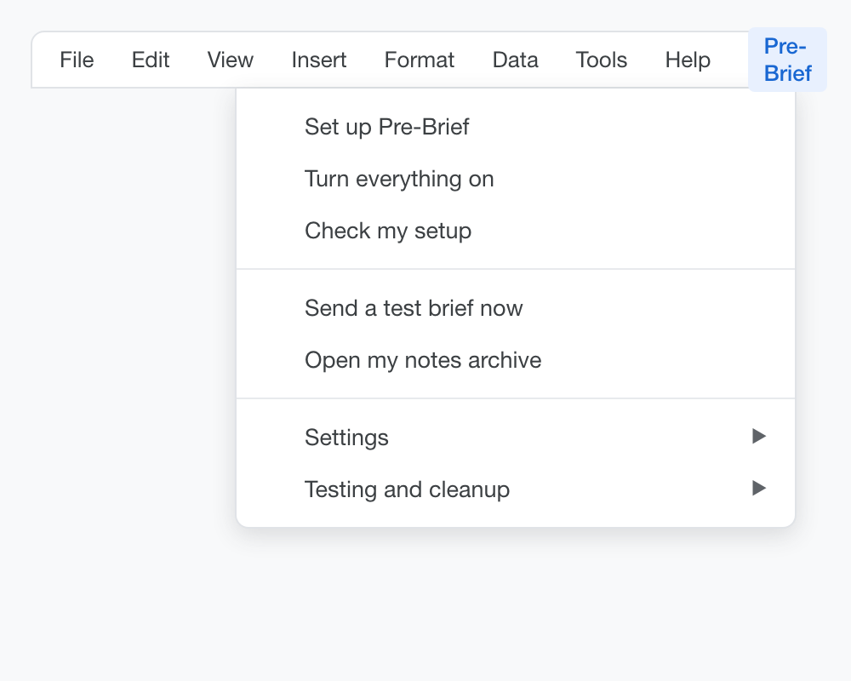
The Pre-Brief menu
You will be asked four questions.
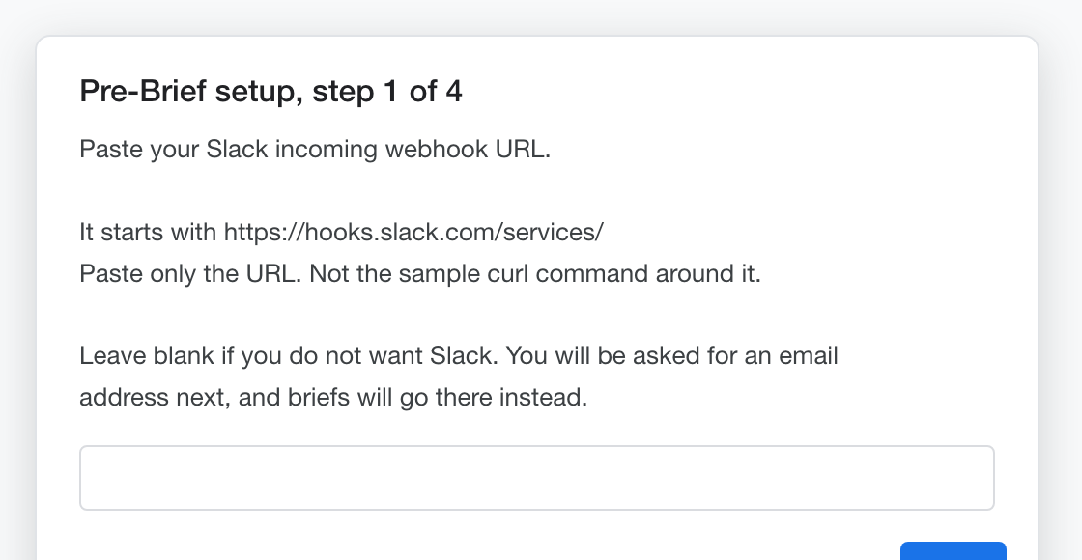
Setup step 1
Question 1. Your Slack webhook.
Paste your incoming webhook URL. It starts with https://hooks.slack.com/services/. Paste only the URL, not the sample curl command Slack shows around it. Setup checks the format and tells you if it looks wrong. See Appendix A if you do not have one yet.
Leave it blank if you do not want Slack. Briefs will go to email instead.
Point the webhook at a private channel with only you in it. See Appendix A. Briefs contain meeting history and open commitments, so the channel should be as private as the Sheet is.
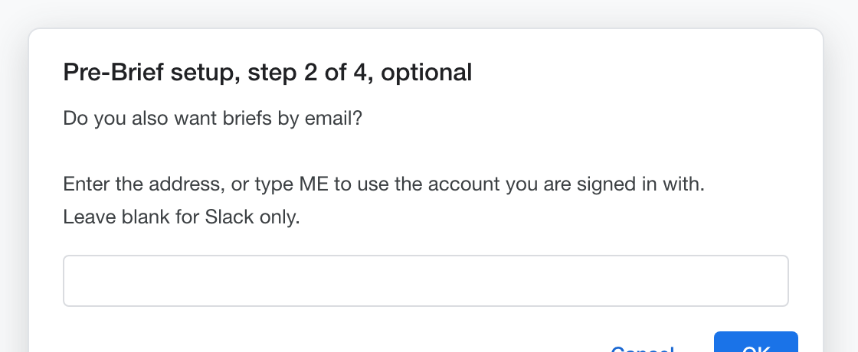
Setup step 2
Question 2. Do you also want briefs by email? Optional.
Enter an address, or type ME to use the account you are signed in with.
Leave it blank for Slack only. If you skipped Slack in question 1, leaving this blank sends briefs to your signed-in account.
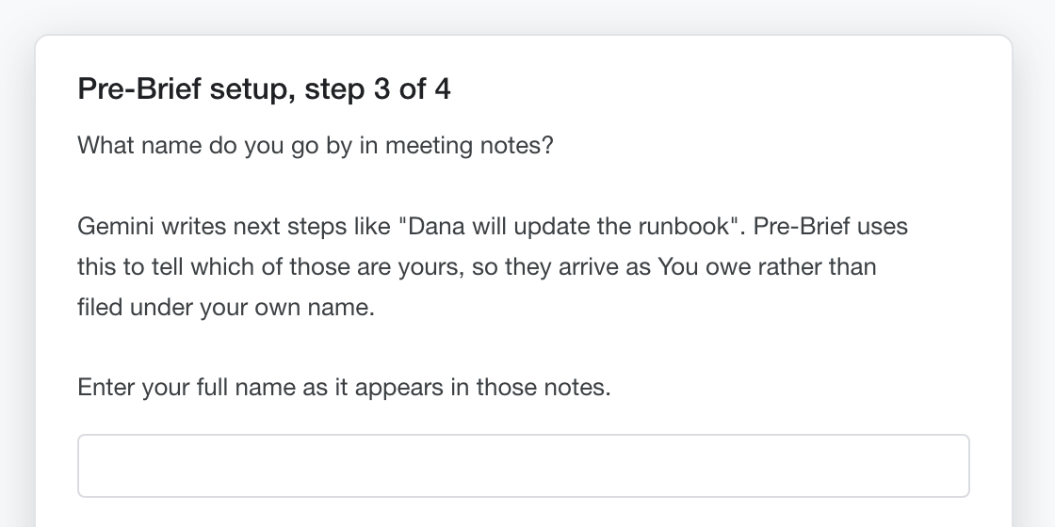
Setup step 3
Question 3. What name do you go by in meeting notes?
Enter your full name as it appears in your meeting notes, for example Austin Arnold.
Gemini writes next steps like “Dana will update the runbook”. Pre-Brief uses your name to work out which of those are yours, so they arrive as You owe instead of being filed under your own name as though you were a third party.
There is no reliable way for a script to look this up. Google’s API for a user’s display name is deprecated and returns nothing, and an address like aa@company.com carries no name at all. So it asks once. You can change it later with Pre-Brief, then Set my name.
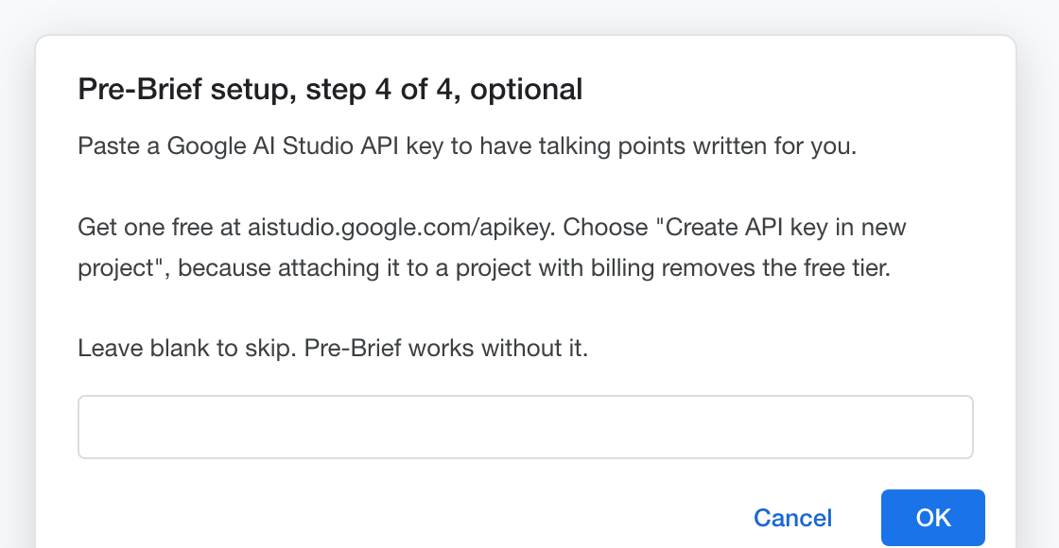
Setup step 4
Question 4. Do you want AI written talking points? Optional.
Paste a Google AI Studio API key, or leave it blank and press OK.
The key powers two things: the recap line that opens each brief, and the sharper version of the suggested talking point.
Blank is a perfectly good answer. Without a key you still get who you are meeting, the last three touchpoints, and every open commitment in both directions, which is the substance. You lose the recap, and the talking point becomes a plain statement of the most pressing commitment rather than a written suggestion. Nothing is left empty. Pre-Brief will use the Suggested Talking Point column in the Contacts tab instead, which you control directly. See the appendix if you want a key.

Step 3. Authorize
The first time setup runs, Google asks permission for the script to use your Calendar, Sheet, and email.
Google asks for Calendar, Sheets, Gmail, and Drive. Drive is what lets Pre-Brief file your meeting notes into per-contact folders. If you never turn note filing on, nothing is ever written to your Drive.
Calendar access is read only in practice. Pre-Brief looks at your events and their attachments. It never attaches anything, never edits an invite, and never creates a meeting, so nothing it does is visible to other guests.
Choose your Google account and click through the consent screens.
You may see a warning that the app is not verified. Whether it appears depends on your account. On a Google Workspace account where you own the script, Google usually treats it as your own app and skips the warning entirely. On a personal Gmail account, or where a Workspace admin has not trusted internal apps, you will see it.
If it appears, it is expected. It refers to the script you just copied, which Google has never reviewed because it is yours. Click Advanced, then Go to (unsafe), then Allow.
If it does not appear, nothing is wrong. Continue through the normal permissions screen.
When it finishes you will see a confirmation, and your Sheet will have six tabs.
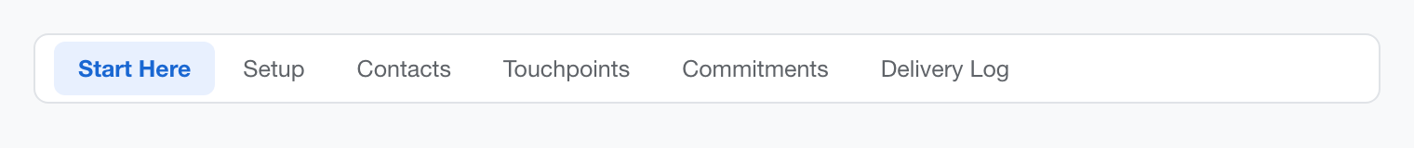
The Sheet tabs
Start Here is the one to read first. It is a plain summary of what now happens automatically and what, if anything, you need to do.

Confirm it works
Send a test. Choose Pre-Brief, then Send a test brief now.
This creates a demo meeting on your calendar 29 minutes out and immediately sends a brief for it. Check your email or Slack. You should have a brief for John Doe.
Check your settings. Choose Pre-Brief, then Check my setup. The Setup tab will show your delivery channel, whether AI talking points are on, and whether automatic briefs are running.
Turn everything on. If you did not do it at the end of setup, choose Pre-Brief, then Turn everything on.
That starts both halves at once: the calendar check that sends briefs, and the daily job that files your meeting notes. There is no second switch to remember.
Test the automatic path. Choose Pre-Brief, then Schedule an unattended test. This creates a meeting 35 minutes out and does nothing else. Walk away. A brief should arrive on its own within about ten minutes. This is the only way to confirm the scheduled path works, so it is worth doing once.
Clean up. Choose Pre-Brief, then Delete demo calendar events, to remove the test meetings.

Step 4. Turn on automatic note filing, optional
Skip this if your meetings do not produce Gemini notes.
Choose Pre-Brief, then File meeting notes now.
Pre-Brief looks back over the past 24 hours of calendar events. Gemini attaches its notes to the meeting invite by itself after a call, and Pre-Brief reads that attachment. For any meeting that has one, it files a copy of the notes into a private Drive folder, writes the summary into Touchpoints, and turns Gemini’s suggested next steps into rows in Commitments.
Which folder depends on who was there. One other attendee files under that person. Two or more files under the meeting title, so “Engineering Standup” builds its own history the same way a person does.
You will get a count of what it filed. If it reports nothing, that is usually correct rather than broken. Notes have to be attached to the calendar event, and an event with no other attendees has nothing to file under.
Check the result. Open the Touchpoints and Commitments tabs and look at the new rows, which are marked Gemini notes in the Source column. Then choose Pre-Brief, then Open my notes archive, to see the folder structure it built.
If you have no meeting notes yet, test it anyway. Choose Pre-Brief, then Run the notes self-test.
This builds two realistic meeting notes documents, attaches them to two calendar events in the recent past, and runs the real filing job against them. One is a 1:1 and one is a four person group meeting, so both paths get exercised. It then prints exactly what it extracted, including which name it resolved for you and why.
It is the fastest way to know the whole chain works before you rely on it. When you are done reading the report, choose Pre-Brief, then Clean up the self-test, which deletes the events, trashes the documents, and removes the rows and folders it created.
The synthetic attendees use example.com, a reserved domain that cannot receive mail, and invitations are suppressed. Nobody is emailed.
Once you are happy with what it wrote, choose Pre-Brief, then Turn on automatic note filing. It will run once a day, early in the morning, so the history is current before your first meeting.
One thing worth knowing. People it has never seen before are added to the Contacts tab automatically, and briefing is on for them by default. There is nothing to approve. Because a first meeting has no prior history, the first brief for a new person arrives before your second meeting with them.
If you ever want to stop briefing on someone without losing their archive, set their Active cell to FALSE.
Sharing the archive. If you are setting this up for an executive, share the top level notes folder with them once. Every contact folder created afterwards inherits that share, so they get the full history on demand without you doing anything again.

Appendix A. Creating a Slack webhook
Skip this only if you decided against Slack.
- In Slack, create a private channel for your briefs, with only you in it.
- This matters more than it looks. Briefs carry meeting summaries and open commitments in both directions. Anyone who can read the channel can read all of it. Make the channel private, do not invite anyone, and do not reuse an existing team channel. Name it something like pre-brief or #my-briefs.
- Incoming webhooks post to a channel, not to a direct message, so a private channel with one member is the right shape. Sending briefs to your own DM is not something a webhook can do reliably.
- Go to api.slack.com/apps while signed in to that workspace.
- Click Create New App, then From scratch.
- Name it Pre-Brief, choose your workspace, click Create App.
- In the left menu click Incoming Webhooks, then turn Activate Incoming Webhooks on.
- Click Add New Webhook to Workspace.
- Choose your briefs channel, then Authorize.
- Copy the webhook URL. Treat it like a password.
A private channel only appears in step 7 if the account installing the app can already see it, which is why you create the channel first.
One honest caveat. A private Slack channel is private from your colleagues, not from your employer. Workspace owners on paid plans can export channel content, private ones included, subject to their retention settings. If you are running this for an executive inside a company workspace and the meeting content is sensitive enough that this matters, use email delivery instead, or a Slack workspace you control.

Appendix B. Getting a Google AI Studio key
Skip this if you are happy writing your own talking points.
- Go to aistudio.google.com/apikey.
- Click Create API key.
- Choose Create API key in new project.
- Copy the key.
Step 3 matters. If you attach the key to a Google Cloud project that has billing enabled, Google removes the free tier entirely. The error that follows reads limit: 0, which looks like a broken key but actually means no free quota is configured. A brand new project avoids this.
Free tier limits are generous relative to this use. Pre-Brief makes one request per brief, so even ten briefed meetings in a day is ten requests.

Appendix C. Adding the key later
If you skip the key during setup and want it afterwards, run Pre-Brief, then Set up Pre-Brief again. It walks the same three questions and overwrites your previous answers.

Turning it off
Stop automatic briefs: Pre-Brief, then Turn off automatic briefs. This stops the scheduled checks. Nothing is deleted.
Stop automatic note filing: Pre-Brief, then Turn off automatic note filing. Notes already in Drive stay where they are.
Stop entirely: delete the Sheet. Everything lives inside it, apart from the notes archive folder in your Drive, which you delete separately if you want it gone.
Revoke access: go to myaccount.google.com/permissions and remove the script.

Pre-Brief v2.7. Installation Guide. August 2026.

